**Course One**

# **Foundations of Data Science**



# **Instructions**

Use this PACE strategy document to record your decisions and reflections as a data professional as you work through this end-of-course project. As a reminder, this document is a resource that you can reference in the future and a guide to help consider responses and reflections posed at various points throughout projects.

# **Course Project Recap**

Regardless of which track you have chosen to complete, your goals for this project are:

* Understand and assess the proposed scenario
* Demonstrate foundational knowledge of the data science workflow - PACE
* Articulate a data project proposal in the planning stage for cross-functional team members

# **Relevant Interview Questions**

Completing the end-of-course project will empower you to be respond to the following interview topics:

* As a new member of a data analytics team, what steps could you take to get 'up to speed' with a current project? What steps would you take? Who would you like to meet with?
* How would you plan an analytics project?
* What steps would you take to translate a business question to an analytical solution?
* Why is actively managing data an important part of a data analytics team's responsibilities?
* What are some considerations you might need to be mindful of when reporting results?

**Reference Guide**

This project has four tasks; the visual below identifies how the stages of pace are incorporated across those tasks.

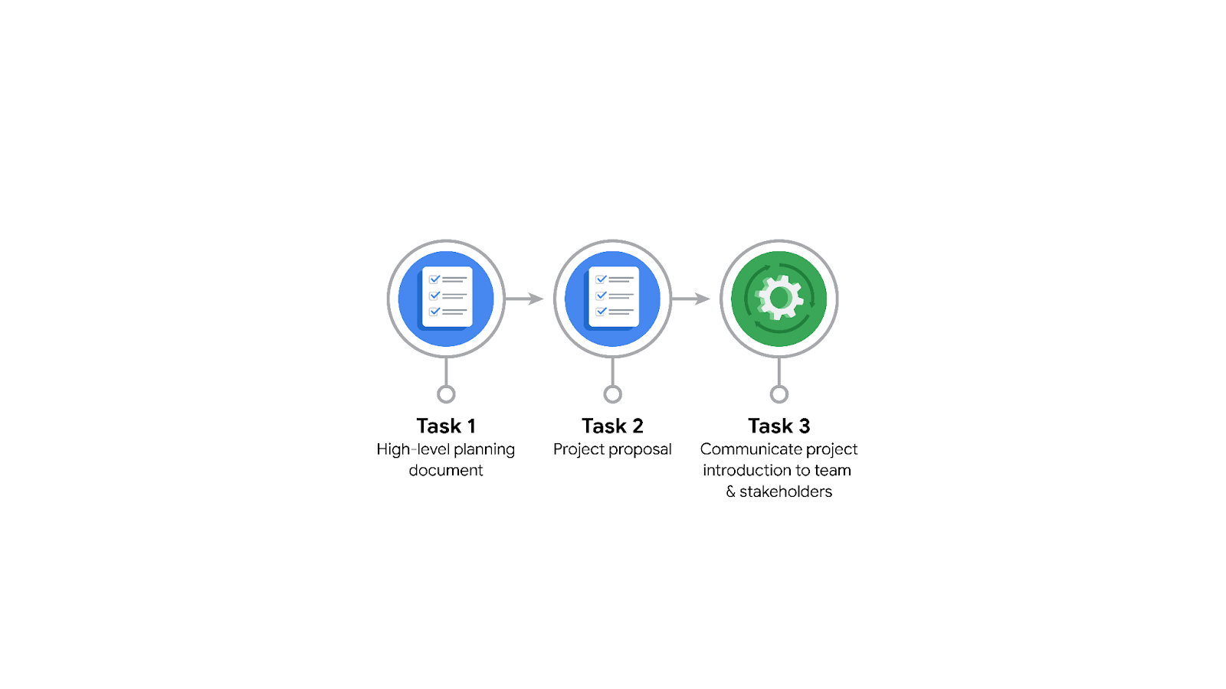

**Data Project Questions & Considerations**

**PACE: Planning Stage**

* Who is your audience for this project?

The audience is the New York City Taxi and Limousine Commission.

* What are you trying to solve or accomplish? And, what do you anticipate the impact of this work will be on the larger needs of the client?

The problem to solve is the duration of rides based on location and time of day.

* What questions need to be asked or answered?
* What is the condition of the provided dataset?
* What variables will be the most useful?
* Are there trends within the data that can provide insight?
* What steps can I take to reduce the impact of bias?
* What resources are required to complete this project?

- Project data set

- Python notebook

- Input from stakeholders

* What are the deliverables that will need to be created over the course of this project?

***The deliverables include:*** *A*data set scrubbed for exploratory data analysis, visualizations, statistical model, regression analysis and/or machine learning model.

## **THE PACE WORKFLOW**

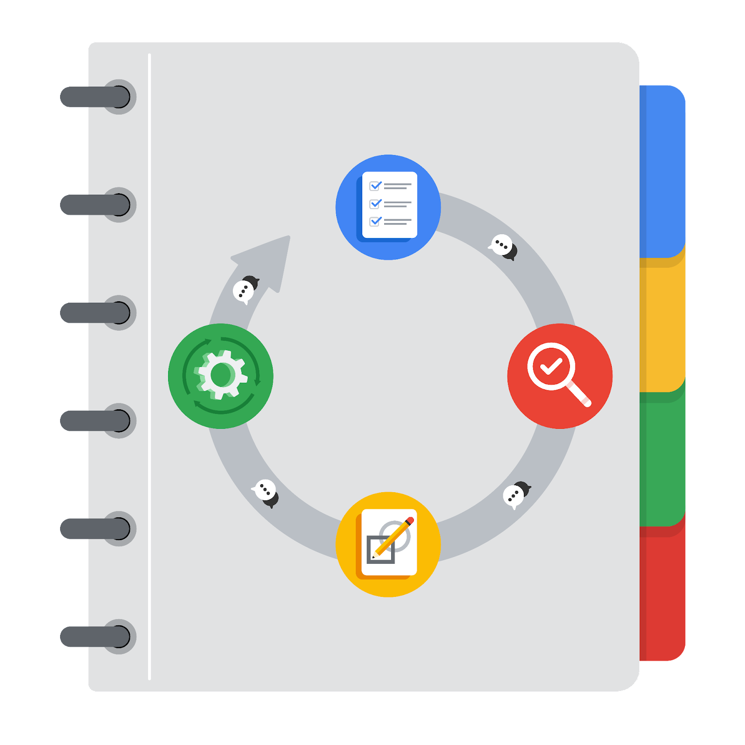

You have been asked to demonstrate for the company's data team how you would use the PACE workflow to organize and classify tasks for the upcoming project. Select a PACE stage from the dropdown buttons. A few tasks involve more than one stage of the PACE workflow. Additionally, not every workplace scenario will require every task. Refer back to the [Course 1 end-of-course portfolio project overview: Automatidata](https://www.coursera.org/learn/google-advanced-data-analytics-first-course-1/supplement/XxgHa/portfolio-project-options-overview-r-501) if you need more information about the tasks within the project.

### **Project tasks**

Below are a group of tasks your company’s data team has determined need to be completed within this project. The data analysis manager has asked you to organize these tasks in preparation for the project proposal document. First, identify which stage of the PACE workflow each task would best fit under using the drop down menu. Next, give an explanation of why you selected the stage for each task. Review the following readings to help guide your selections and explanation: [The PACE stages](https://www.coursera.org/learn/foundations-of-data-science/supplement/4OtHr/the-pace-stages) and [Communicate objectives with a project proposal](https://www.coursera.org/learn/foundations-of-data-science/supplement/79Ysh/communicate-objectives-with-a-project-proposal). You will later reorder these tasks within a project proposal.

1. **Evaluating the model: Execute**

Why did you select this stage for this task?

After the model has been constructed, data is run through to evaluate whether it meets the project’s expectations and goals.

1. **Conduct a hypothesis test: Construct and Analyze**

Why did you select these stages for this task?

During the analyzing stage, it is determined that a statistical test will be used. During the construction phase, the test is carried out.

1. **Understanding the data: Analyze**

Why did you select this stage for this task?

Analyzing stage. When cleaning and formatting, you will gain a deeper understanding of your data.

1. **Data exploration and cleaning: Plan** **and Analyze**

Why did you select these stages for this task?

Planning takes place when you first make choices about the methods needed. The cleaning process then takes place in the analyzing stage.

1. **Establish structure for project workflow (PACE): Plan**

Why did you select this stage for this task?

Planning stage. Creating an initial project PACE document outlines the workflow and helps to plan how to best approach a project.

1. **Communication final insights with stakeholders: Execute**

Communication is necessary at various points throughout a project. Final insights are shared with stakeholders in the execute phase of the data project workflow.

1. **Compute descriptive statistics: Analyze**

Why did you select this stage for this task?

Investigating the statistics within data takes place during the analysis process.

1. **Visualization building: Construct and Analyze**

Why did you select these stages for this task?

Visualization begins with data assessment and is created during the construction stage.

1. **Write a project proposal: Plan**

Why did you select this stage for this task?

Planning stage. A project proposal is the initial document used to define a project.

1. **Build a regression model: Construct and Analyze**

Why did you select this stage for this task?

The regression model is first constructed. Then, during the analyzing stage the model is examined in detail to be sure it will meet the needs of the task.

1. **Inspect the data set for missing data: Analyze**

Why did you select this stage for this task?

Analyzing stage. Inspecting a data set for missing data would take place while assessing the quality of your data.

1. **Build machine learning model: Construct**

The building of a data model would take place in the construct stage.